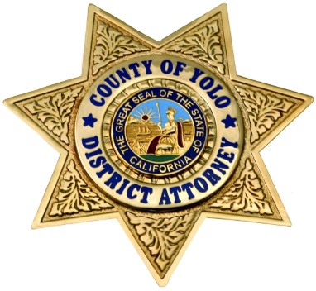
County of Yolo
Office of the District Attorney
Jeff W. Reisig, District Attorney
301 Second Street - Woodland, California 95695 - 530.666.8180 - Fax 530.666.8185

FOR IMMEDIATE RELEASE

Date: May 28, 2021 Contact: Jonathan Raven, Chief Deputy DA
Jonathan.raven@yolocounty.org
Bilingual Spanish Representative Available
at (530) 666-8356

Yolo DA’s Office’s New Public Data Tool Reveals Racial Disparity in Cases Sent to Prosecutor’s Office, Inspires Immediate Policy Change

New Policy Will Prevent Defendants with Criminal Histories from
Automatically Being Disqualified from Diversion

(Woodland, CA) – May 28, 2021 – The Yolo County District Attorney’s Office’s transparency portal, launched on April 6, 2021, is already driving policy change. As a result of data now made available through the portal, Commons, the office has changed policy to ensure more cases--particularly those involving defendants of color--are diverted out of the criminal justice system.

The policy change means the office will no longer automatically disqualify an individual from being referred to a diversion program based on their criminal history, and is estimated to increase diversions by 15%-20%. Diversion allows an offender to participate in a program that helps remedy the behavior leading to the original arrest and also holds the offender accountable. Upon completion of the diversion program, the offender avoids a conviction or criminal record. The policy change is the first of many to come that will be driven by data from Commons.

“The Commons data portal shows us clear trends that could contribute to racial disparities in the criminal justice system,” said Jeff Reisig, Yolo County District Attorney. “We can see in the data that people of color are disparately represented in cases referred to our office from our local law enforcement agencies. Because criminal history is one of a number of factors determining diversion eligibility, people of color could be disproportionately denied the opportunity for their cases to be diverted before trial.”

According to a May 2017 report by the Quattrone Center for the Fair Administration of Criminal Justice, people of color involved in the criminal justice system often have pre-existing differences reflected in their criminal record based on previous encounters with the criminal justice system.

“This criminal history has a ripple effect that impacts how these individuals’ cases are handled by the justice system,” said Reisig. “In the past, people with prior records never made it to the starting line. Now, when my charging deputies review most cases to determine diversion eligibility, they won’t be focusing on the person’s criminal history. Down the road, Commons will tell us whether this new policy change made a difference.”

Reisig qualified that victim input is always sought, and diversion will not be allowed for cases alleging domestic violence, driving under the influence, sexual assault, or hate crimes.

To develop this new policy, the District Attorney sought the input of the Yolo County Multi-Cultural Community Council. MCCC Chair Tessa Smith said, “This policy change demonstrates how Commons can bring accountability to agencies, drive change in criminal justice practices, and reveal inequities to be addressed in our criminal justice system. It’s a game changer!”

Over the past year, the District Attorney partnered with Measures for Justice, a non-profit organization on a mission to make accurate criminal justice data available to spur reform, to develop Commons, which is a first-of-its-kind online data dashboard that tracks local criminal justice data on a monthly basis alongside a policy goal embraced by the DA and community leaders.

Commons is unique in that the county data is validated and posted by Measures for Justice, a neutral third party. The data is not controlled internally by the District Attorney’s office, unlike other portals across the nation. The dashboard is also the first to seek community input in terms of what data they want to see.

Measures for Justice CEO, Amy Bach, said, “Yolo is using Commons exactly how we had envisioned it. Commons data from Yolo is driving new policy changes that address issues of racial disparity. We are very excited that less than 60 days after the Commons’s launch, we are already seeing a difference.”
###

