COUNTY OF KINGS  Office of the County Counsel  KINGS COUNTY  GOVERNMENT CENTER  1400 W. LACEY BLVD.  LAW BLDG. NO. 4  HANFORD, CA 93230  TEL: (559) 852-2445  FAX: (559) 584-0865 |  | 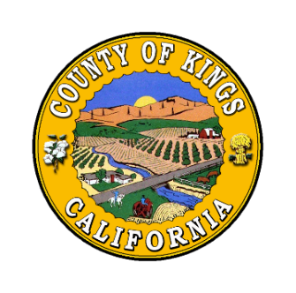
  DIANE FREEMAN
  County Counsel
  Deputies:
  RISÉ A. DONLON
  FRANK A. RUIZ
  THOMAS Y. LIN
  CINDY CROSE KLIEVER
  SEAN CASH
  SUSAN M. FISHER

January 27, 2023

Via Electronic Mail:
Wilner@braunhagey.com

Josh Wilner
BraunHagey & Borden LLP
351 California Street, 10th Floor
San Francisco, CA 94104

Re: California Public Records Act Request Dated July 23, 2021

The County of Kings (“County”) is in the process of identifying, locating, and reviewing additional documents potentially responsive to your California Public Records Act (”CPRA”) request of July 23, 2021. You will be provided with an update and/or responsive documents no later than February 24, 2023.

If you have any questions, you may contact this office at the telephone number and/or address above, or via e-mail at Sean.Cash@co.kings.ca.us. Thank you.

Sincerely,

DIANE FREEMAN
County Counsel

SEAN CASH
Deputy County Counsel

2021-46-870 [478337]

