To reach some of the core attorney resources about our digital systems, you can access the internal website: MySLO.

MySLO is for all County employees, but is customized for employees of each department. You’ll see a “toolbox” that is set for DA’s Office employees.

- Click on this icon on your desktop:
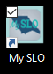

- In the “toolbox” you can click into various links, e.g. for CEB, PbK (although you will most likely use the PbK icon on your desktop for this), and the DA Page.
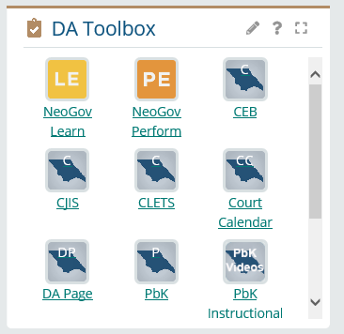

NOTE:
- Attorneys do not have access to CLETS-- that access is only for certified legal clerks and investigators.
- The link to PbK Instructional videos here will take you to videos that the software company, Karpel, has made. I suggest you view the “PbK 101 Training” video, just to get an overview of how the software is set up. Karpel serves prosecutors’ offices all over the country, so each county has the software configured for their use, but the basic structure and features are the same. In the list of videos, look for this:


- From the DA Page, click into Attorney Resources and Training
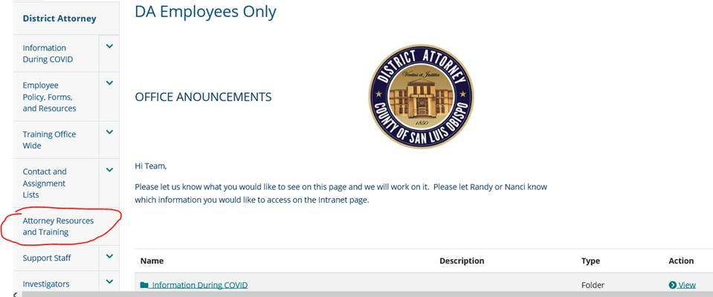

- Here’s what you see in Attorney Resources and Training (it’s all related to digital tools except the Pre-Filing Misd. Diversion Program link – that covers the criteria and processes for our DA pre-filing misdemeanor diversion program):

